## horizontal line



Line Following Robot

15.09.2019

**─**

C Vijayabaskar & G Velmurugan

2017103048 & 2017103047

B.E CSE 3rd year

# 

# Overview

The line follower robot is a mobile machine that can detect and follow the line drawn on the floor. Generally, the path is predefined and can be either visible like a black line on a white surface with a high contrasted color or it can be invisible like a magnetic field.

# Objectives

Definitely, this kind of robot should sense the line with its infrared ray (IR) sensors that installed under the robot. After that, the data is transmitted to the processor by specific transition buses. Hence, the processor is going to decide the proper commends and then it sends them to the driver and thus the path will be followed by the line follower robot. In this Paper, we have illustrated the process of design, implementation and testing TABAR, a small line follower robot designed for the line follower robots competition.

# Specifications

• ATmega8 microcontroller - 72

• Motor driver IC (L293D) - 165

• Motors (2 no s) - 40

• Resistors-R1 to R4. - 8

• IR transmitters – IR TX1, IR TX2 - 40

• IR Receivers -IR RX1, IR RX2 - 124

# Design diagram

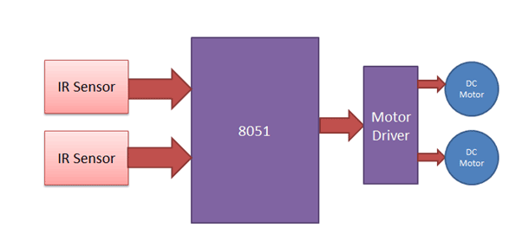

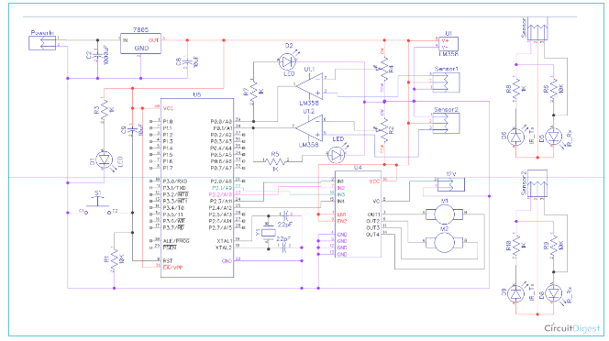

# 

# Implementation details

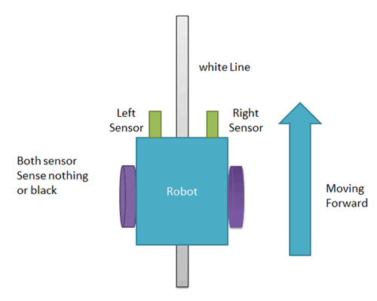 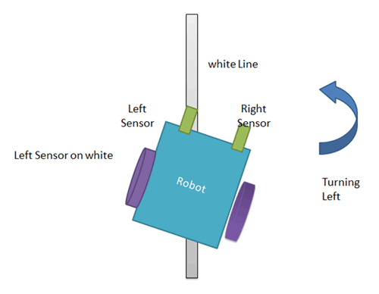

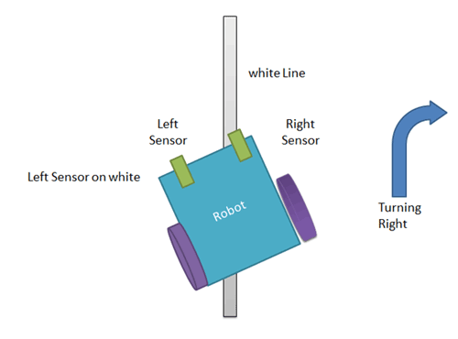 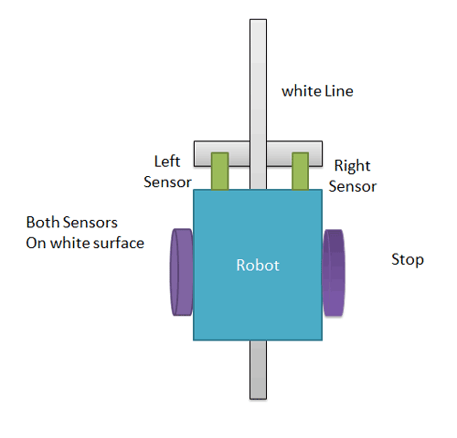

1. When left sensor senses white line then robot turn left side.

2. When left sensor sense white line then robot turns to right side until both sensor comes at black line or senses nothing surface.

3. When both sensors comes on white line, robot stop.

# Deliverables

Here in this project we are using two IR sensors pair. Suppose we are calling left sensor and right sensor of IR sensor Pair, then both left and right sensors sense nothing or black line then robot move forward.

Line follower robot senses white line by using sensor and then sends signals to microcontroller. Then microcontroller drives the motor according to sensors' output.

This can be used in driver less car system with some added features like obstacle detection.

This can also be used in industrial and defense applications.

So the robot can be delivered as the product of a development process.

# Verification and validation

1. Initially draw the path on the chart with black color.

2. Place the robot on the chart.

3. Now power the circuit.

4. Robot moves in the specified path.

5. When it moves out of path, sensors check it and automatically adjust the robot.

6. We have also done this testing in rough paths.

7. But we have to keep track on some constrains while driving the robot on those rough paths.

8. We have also tested it with some obstacles on the specified path.

# References

<https://circuitdigest.com/microcontroller-projects/line-follower-robot-using-8051-microcontroller>

<https://www.electronicshub.org/line-follower-robot-using-microcontroller/>